## ***Analysis of Global Renewable Energy Production (2000-2023) Data Set***

***Abstract***

This report looks at the "Global Renewable Energy" dataset to see the trends and patterns in renewable energy production around the world. The analysis involves cleaning the data, creating visualizations, and evaluating the statistics of different renewable energy sources over the years.

***Introduction***

Renewable energy is essential in the global fight against carbon emissions and climate change. This report uses a dataset from Kaggle to explore the trends and growth of renewable energy production around the world.

### *Methodology*

#### **Data Collection**

The dataset was obtained from Kaggle and includes various attributes related to renewable energy production.

kaggle datasets download -d ahmedgaitani/global-renewable-energy

#### **Data Preprocessing**

The dataset was loaded into R, and necessary preprocessing steps such as handling missing values and converting data types were performed.

Load the Data:

* By loading the sales data into analysis tool, we can see what we have to work with.

library(readr)

global_energy <- read_csv("C:/Users/dulmi/Downloads/global_renewable_energy_production.csv")

head(global_energy)

Clean the Data:

**Summarize the data**

summary(global_energy)

Clean the Data:

* We will check is there any missing or incorrect values and clean them up.

colSums(is.na(global_energy))

#### **Data Analysis**

Exploratory data analysis (EDA) and visualizations were conducted to understand the distribution and trends in the data.

***SolarEnergy***

freq.global_energy.SolarEnergy = table(global_energy$SolarEnergy )

freq.global_energy.SolarEnergy

***WindEnergy***

freq.global_energy.WindEnergy = table(global_energy$ WindEnergy )

freq.global_energy.WindEnergy

***HydroEnergy***

freq.global_energy.HydroEnergy = table(global_energy$HydroEnergy )

freq.global_energy.HydroEnergy

***OtherRenewableEnergy***

freq.global_energy.OtherRenewableEnergy=table(global_energy$ OtherRenewableEnergy )

freq.global_energy.OtherRenewableEnergy

***Results and Evaluation***

***# Load necessary libraries***

library(ggplot2)

***# Load the dataset***

library(readr)

global_energy <- read_csv("C:/Users/dulmi/Downloads/global_renewable_energy_production.csv")

head(global_energy)

**# Summary of the dataset**

summary(global_energy)

***# Check the structure of the dataset***

str(global_energy)

***# Check for missing values***

colSums(is.na(global_energy))

***# Handle missing values (if any)***

global_energy <- na.omit(global_energy)

***b***

B

#### **Data Visualization**

1. **Scatter Plot: Total Renewable Energy Production Over the Years**

r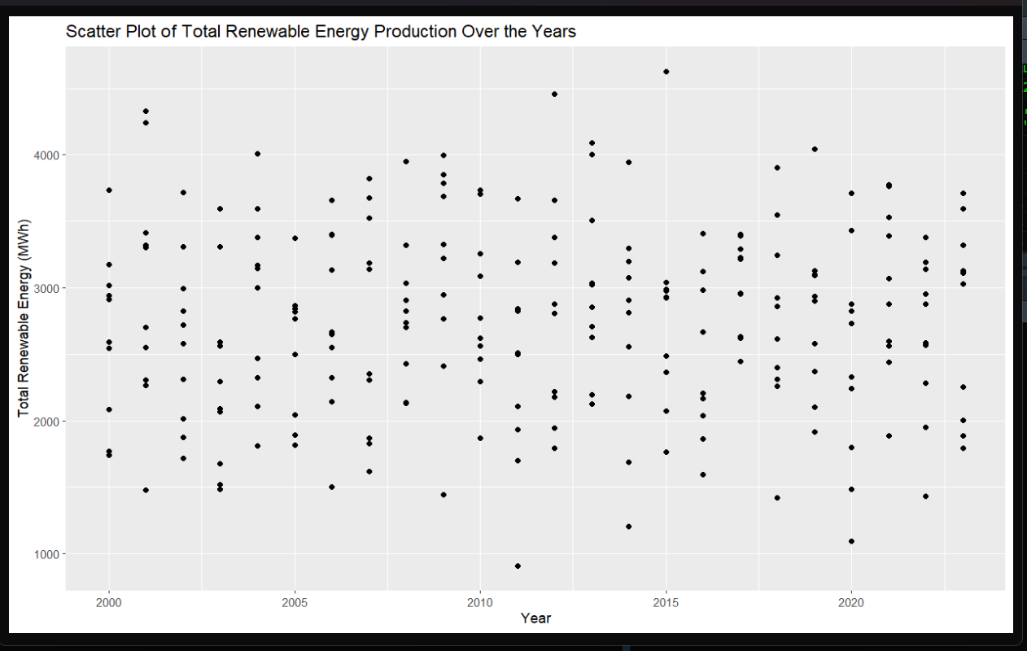

**Histogram of WindEnergy**

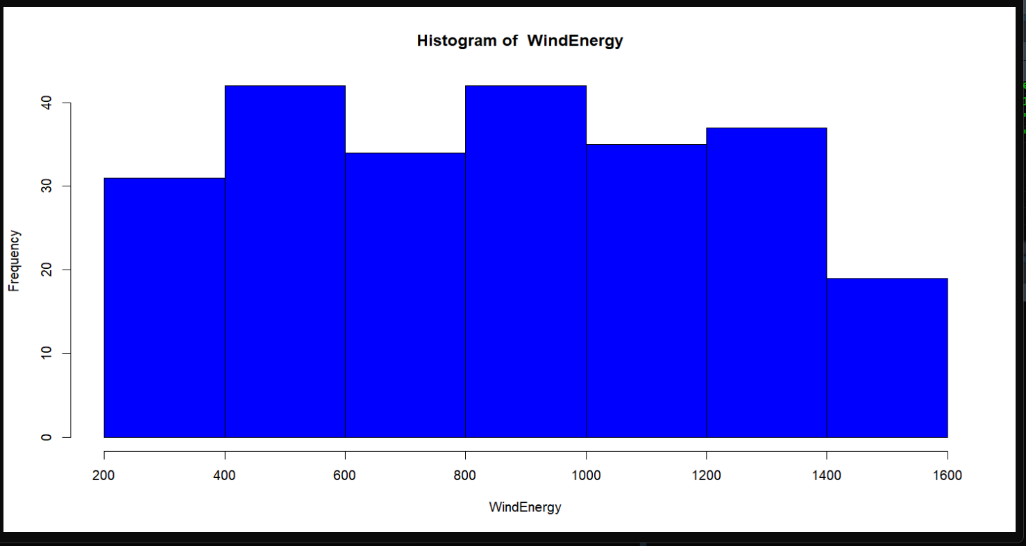

***Histogram of SolarEnergy***

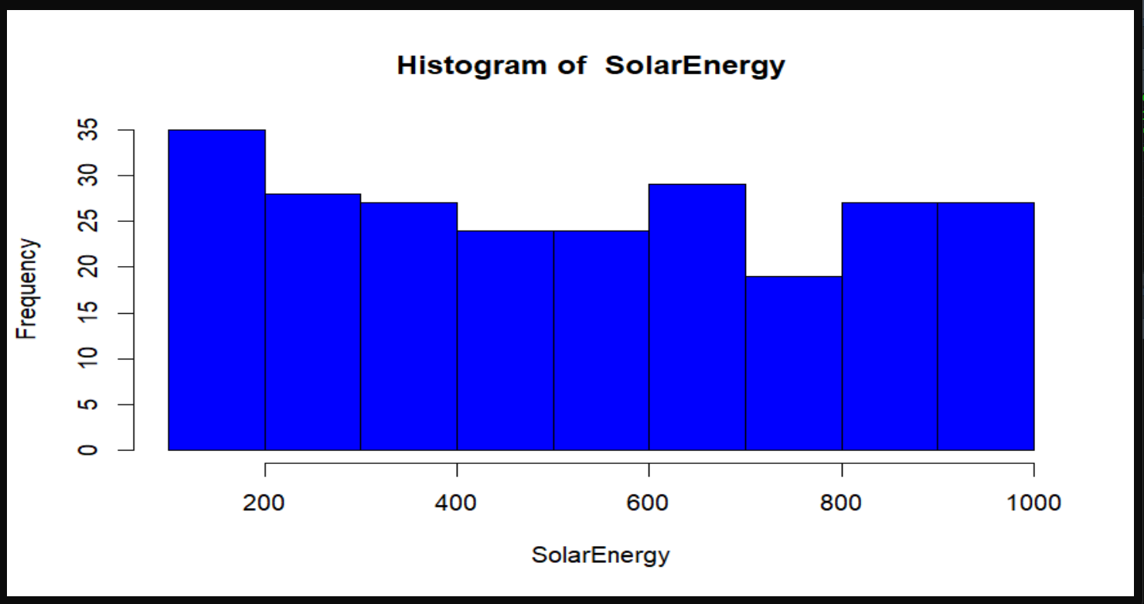

***Histogram of HydroEnergy***

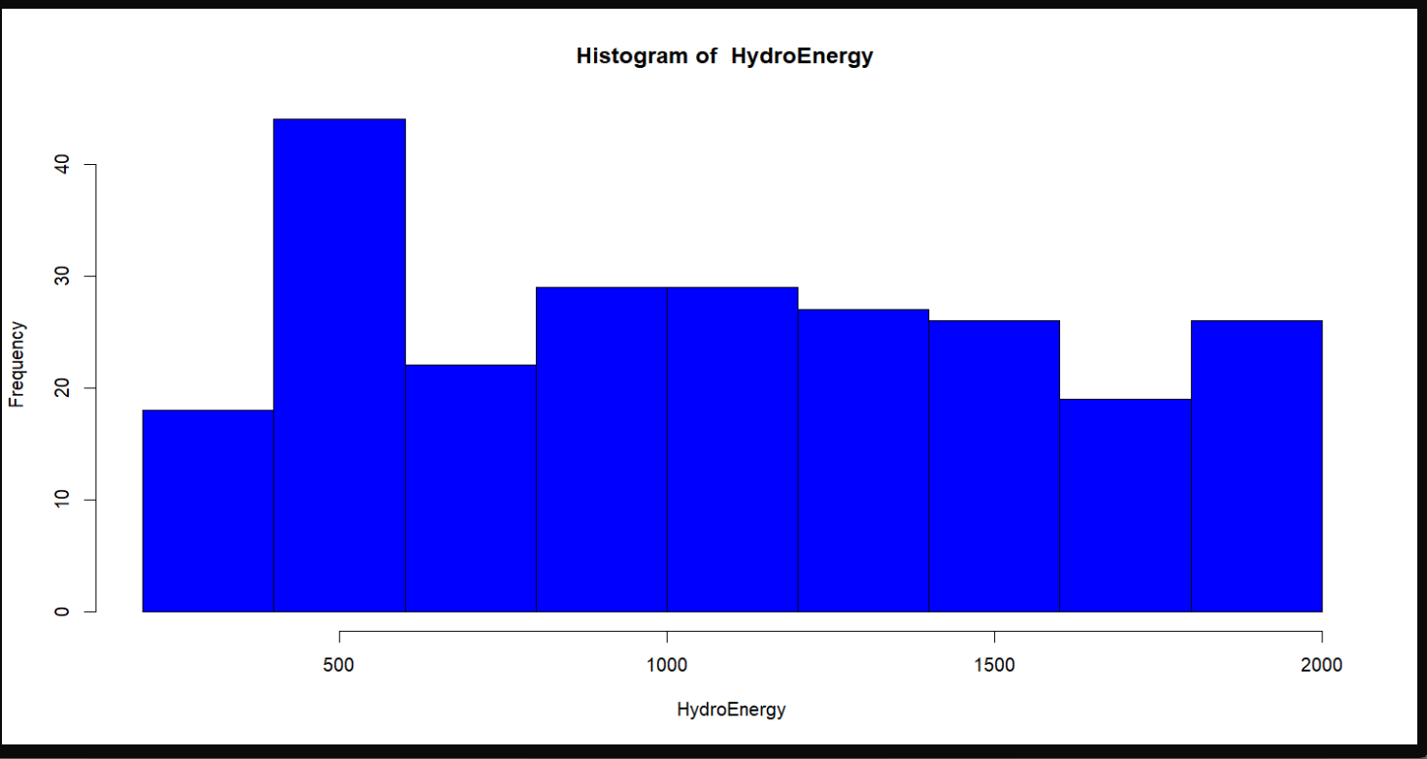

***Histogram of OtherRenewableEnergy***

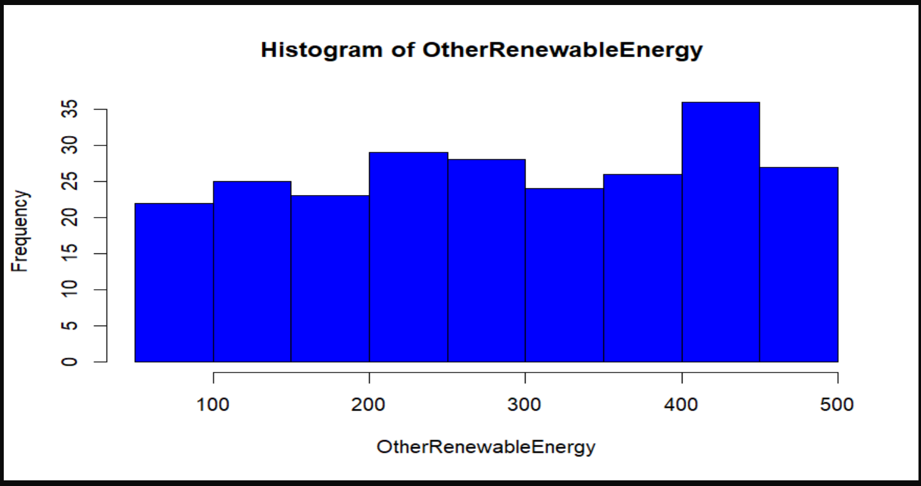

### *Conclusion*

The analysis of the "Global Renewable Energy" dataset reveals significant trends in renewable energy production over the years. The visualizations indicate a steady increase in renewable energy production, with notable contributions from solar and wind energy. This trend underscores the growing importance of renewable energy in the global energy mix, highlighting the need for continued investment and policy support to sustain this growth.

By conducting this analysis, we gain a deeper understanding of the progress made in renewable energy adoption and can identify areas that require further attention and research.